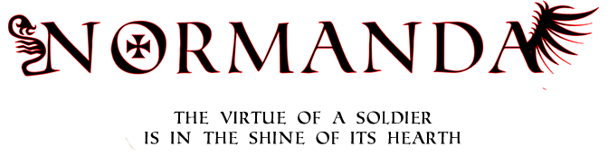

Normanda Production Plan

Written by Gabriel Vergari & Nuno Teixeira

20th of November

# 1. First Sprint

## 1.1 Normanda Unity Game

|  |  |  |  |  |  |
| --- | --- | --- | --- | --- | --- |
| Task | Time Needed | Responsable | Tested? | Priority | Stage |
| Camera | 0.5 Hour | Gabriel | Yes | High | Completed |
| Player Movement | 0.5 hour | Gabriel | Yes | High | Completed |
| Player Animation | 2.5 Hours | Gabriel | Yes | Low | Completed |

### 1.1.1 Normanda Unity Game For The Next Sprint

|  |  |  |  |  |  |
| --- | --- | --- | --- | --- | --- |
| Task | Time Needed | Responsable | Tested? | Priority | Stage |
| Player Basic Attack | X Hour | Gabriel | Yes | High | Not Started |
| Player Strong Attack | X Hour | Gabriel | Yes | High | Not Started |
| Player Shield | X Hour | Gabriel | Yes | High | Not Started |

## 1.2 Normanda Companion App

|  |  |  |  |  |  |
| --- | --- | --- | --- | --- | --- |
| Task | Time Needed | Responsable | Tested? | Priority | Stage |
| Blueprints | 3.5 Hour | Gabriel & Nuno | Yes | High | Completed |

### 1.2.1 Normanda Companion App For The Next Sprint

|  |  |  |  |  |  |
| --- | --- | --- | --- | --- | --- |
| Task | Time Needed | Responsable | Tested? | Priority | Stage |
| App Pages/Connected | X Hour | Gabriel | Yes | High | Not Started |

## 1.3 Objectives

In-game character is moving and the camera is working properly for the type of game.

## 1.4 Backlogs

The Task in both game and the app backlogs were done as envisioned them.

## 1.5 Sprints

The Tasks were completely done by their responsable.

## 1.6 Analysis

In this sprint, most of the work was done by brainstorming and having discussions with the teachers about the mechanics. The Database was sketched to simplify future work.

## 1.7 Tasks Review

All tasks were completed without any delay or change on the backlogs.